DIRECTIONS TO CITIGROUP CENTER TAMPA
3800 Citigroup Center
Tampa, FL 33610
Located in Sabal Park at I-75 & Hwy. 574/Martin Luther King Blvd.

From I-275:
Take I-275 to I-4 East to I-75 South. Take I-75 Exit 260 [old 52] [exit also known as Mango, Hwy. 574/Martin Luther King Blvd.]. Turn West on Martin Luther King Blvd. and get in the left lane. The Sheraton Hotel will be on the left. Proceed to the traffic light at the intersection of MLK Blvd. and Falkenburg Road and turn left on Falkenburg. Take the next left on Princess Palm Drive. Turn right at the intersection [Queen Palm Drive]. Proceed to Citigroup Center on your right.

From I-275 / Tampa International Airport:
Take the Airport Access Road south and follow signs for I-275 North to I-4 East to I-75 South. Take I-75 Exit 260 [old 52] [exit also known as Mango, Hwy. 574/Martin Luther King Blvd.]. Turn West on Martin Luther King Blvd. and get in the left lane. The Sheraton Hotel will be on the left. Proceed to the traffic light at the intersection of MLK Blvd. and Falkenburg Road and turn left on Falkenburg. Take the next left on Princess Palm Drive. Turn right at the intersection [Queen Palm Drive]. Proceed to Citigroup Center on your right.

From I-75:
From I-75 South, take Exit 260 [old 52] [exit also known as Mango, Hwy. 574/Martin Luther King Blvd].

From I-75 North, take Exit 260B [exit also known as Mango, Hwy. 574/Martin Luther King Blvd].

Then turn West on Hwy. 574/Martin Luther King Blvd. and get in the left lane. The Sheraton Hotel will be on the left. Proceed to the traffic light at the intersection of MLK Blvd. and Falkenburg Road and turn left on Falkenburg. Take the next left on Princess Palm Drive. Turn right at the intersection [Queen Palm Drive]. Proceed to Citigroup Center on your right.
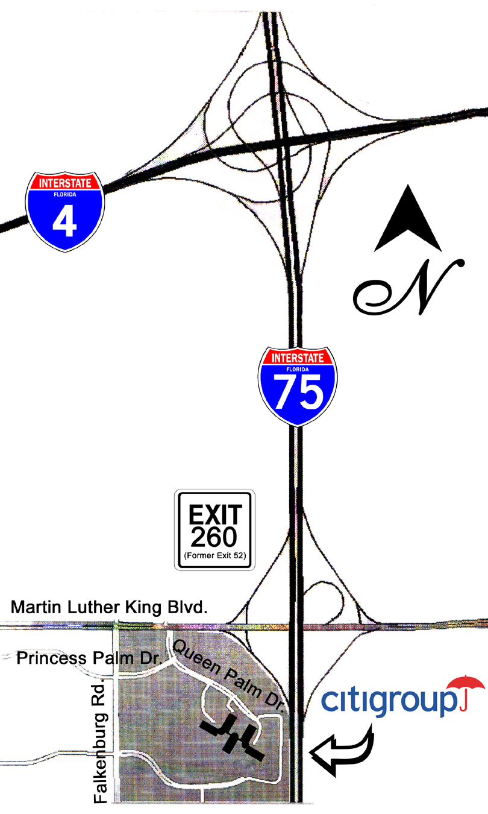

From I-4 West [Orlando]:
Take I-4 Exit 7 to I-75 South. Take I-75 Exit 260 [exit also known as Mango, Hwy. 574/Martin Luther King Blvd.]. Turn West on Martin Luther King Blvd. and get in the left hand lane. The Crowne Plaza Hotel will be on the left. Proceed to the traffic light at the intersection of MLK Blvd. and Falkenburg Road and turn left on Falkenburg. Take the next left on Princess Palm Drive. Turn right at the intersection [Queen Palm Drive]. Proceed to Citigroup Center on your right.

From Hyatt Regency Westshore/Tampa:
As you exit the hotel, turn right on the causeway and follow the signs to Rt. 60 to I-275 North. Then follow the above directions from I-275.

Picture ID is required for access to Citigroup:
Visitors must present a picture ID at the Security Desk in order to have a Visitor’s Badge issued. You may be asked to open your briefcase and/or handbag.

Parking: There will be volunteers assisting with parking. There is a parking lot directly across from Citi (behind the Sheraton Hotel) which will be available for your use.

No cameras are allowed on premises.
Thank you.

